**ECE 792: Senior Project II – Spring 2018**

**Advisor: Se Young (Pablo) Yoon, Ph.D.**

**Project: SEDS Rocket Club**

**Presented By: Daniel Nemr**

**Team Members: Daniel Nemr, Nick Clegg, Pedro S. Campos, Charlie Nitschelm, Ross Thyne, Morgan Saidel, Reilly Webb, Chris Smith, Matt Dodge, Kristian Comer, Kevin Bucher**

**Department of Electrical and Computer Engineering**

**University of New Hampshire**

**ECE Courses Involved: 633, 634, 541**

**Final Report Date: April 25, 2018**

**Expected Project Completion Date: May 9, 2018**

**Executive Summary**

The purpose of this project is to make a team effort to design and construct a two-stage high power rocket that will compete in this year’s annual SEDS (Students for the Exploration and Development of Space) USRC (University Student Rocket Competition). This project teaches how to interact with a team as well as how to work through the life cycle of product development which are common practices in industry. The three electrical components researched and designed in this project are an electrical launcher, a stabilization system, and parachute deployment of a two-stage high power rocket. The components mentioned are ones that will continue to improve as the SEDS club seeks yearly improvements to all aspects of rocketry. The club started this year at UNH and has already made great strides in research and understanding of how rockets work as well as how to construct them. Overall, this project has been enjoyable and professional in all efforts to complete one goal, win this year’s USRC as well as others to come.

**Table of Contents**

Project Overview and Motivation 4

Electrical Launcher 5

Stabilization System 10

Parachute Deployment………………………………………………………………………………………………………. 17

Budget ………………………………………………………………………………………………………………………………. 21

Timeline (Gantt Chart)……………………………………………………………………………………………………….. 26

**Ethical Consideration…………………………………………………………………………………………………………. 26**

**Safety………………………………………………………………………………………………………………………………… 27**

**Standards Utilized……………………………………………………………………………………………………………… 29**

**Contributions of Each Member………………………………………………………………………………………….. 29**

Conclusions……………………………………………………………………………………………………………………….. 31

**Recommendations of Future Work……………………………………………………………………………………. 32**

**References………………………………………………………………………………………………………………………… 35**

**Appendices……………………………………………………………………………………………………………………….. 36**

**Project Overview**

The goal of this project was to create a high-power rocket that will be entered in this year’s annual SEDS USRC. To complete this objective, a team of mechanical and electrical engineers, as well as computer science majors was assembled. Each member on the team was assigned specific tasks for the project based on their academic background. The electrical engineers were delegated to design a stabilization system, electrical launcher, and the parachute deployment of the rocket. The objective was to complete all electrical components of the rocket on-time and within budget as shown in Tables 3 and 4 in this document. The results of this project were presented at the University of New Hampshire Research Conference.

The objective of the USRC is to create a two-stage high power rocket which will compete against other SEDS rockets from across the US. To win this competition, the rocket must fly higher in altitude than all other rockets. This competition is relevant because it allows students to work as a team and become creative on how to design the rocket. Working as a team, communicating to others, and meeting deadlines are common practices in industry, so this project played a big part in demonstrating applicable skills to potential employers.

**Lead Role**

My role per agreement/recommendation of the club founder, Charlie Nitschelm, was to undertake a lead role in the development of the three major electrical components of the rocket. These three components were the Launcher System, Stabilization System, and Parachute Deployment. I conducted weekly meetings with a team of electrical engineering as well as computer science majors to make sure the tasks were on track to be completed on time and within budget.

**Electrical Launcher**

# General Description

There were three purposes to the electrical launcher. First, the launcher had to deliver enough electrical current to start the igniter, which would then start the engine motor. Second, the launcher had to include a safety mechanism so that it was safe for someone to prep the rocket for launch. Lastly, the launcher had to guide the rocket until it attained enough airspeed for the stabilization system to safely guide the rocket.

The team also had to follow the National Association of Rocketry (NAR) Safety Code for high-power rocketry. The safety code contains sections that reference how the launch system should be designed. Here are the relevant sections.

**Ignition System:** The rocket will be launched with an electrical launch system and electrical motor igniters. The launch system will have a safety interlock in series with the launch button, and will use a launch button that returns to the "off" position when released.

**Launch Safety:** We will use a countdown before launch, and will ensure that everyone is paying attention and is a safe distance of at least 15 feet away when the rocket is launched with D motors or smaller, and 30 feet when use larger rated motors. If we are uncertain about the safety or stability of an untested rocket, we will check the stability before flight and will fly it only after warning spectators and clearing them away to a safe distance.

**Launcher:** We will launch the rocket from a launch rod that is pointed within 30 degrees of the vertical to ensure that the rocket flies nearly straight up, and I will use a blast deflector to prevent the motor's exhaust from hitting the ground. To prevent accidental eye injury, I will place launchers so that the end of the launch rod is above eye level or will cap the end of the rod when it is not in use.

How the Launcher Works

The launcher system must have enough current to ignite the motor. Commercial electrical igniters need around 1.5 amps of current for at least one full second to fully ignite a single rocket ignition. Igniters get hot when large amounts of current are applied because they’re made of nichrome which has high resistance due to electrical flow and does not melt until it is very hot (2000 degrees). The heat that is dissipated ignites the pyrogen that coats the wire. The pyrogen flashes and a small flame from the igniter starts the motor. Commercial launchers use anything from two AA (3 Volts) up to two R/C battery packs (14 Volts), but this project used a 12 V battery because that was more than enough voltage to supply enough current to the output, and it was cheap. To ensure that we got enough current at the output, resistance was kept as low as possible by using larger wires (smaller AWG) and choosing materials that are better electrical conductors. Copper is a better electrical conductor and has a lower resistance than aluminum as shown in Table 1. Since the team must have been at least 30 feet away from the rocket before and during launch, 16-gauge copper wire was used for the electrical launcher. Figure 1 shows the original schematic for the launcher and Figure 2 shows the final schematic. There were modifications to the schematic because the buzzer was extremely loud. The buzzer was 90 db which was equivalent to the sound of a motorcycle 25 ft. away. Figure 3 shows the box of the launcher that was built for the project. Figures 4 and 5 show the launcher when it is off and when the switch is turned on respectively. Figure 6 explains how the launcher works.

|  |  |  |
| --- | --- | --- |
| Wire Gauge (AWG) | Copper Wire  Ohms per 10 feet of wire | Aluminum Wire  Ohms per 10 feet of wire |
| 12 | 0.01588 | 0.089 |
| 14 | 0.02525 | 0.138 |
| 16 | 0.04016 | 0.221 |
| 18 | 0.06385 | 0.350 |
| 20 | 0.1015 | 0.556 |
| 22 | 0.1614 |  |

**Table 1: Chart of Resistance Between Aluminum and Copper**

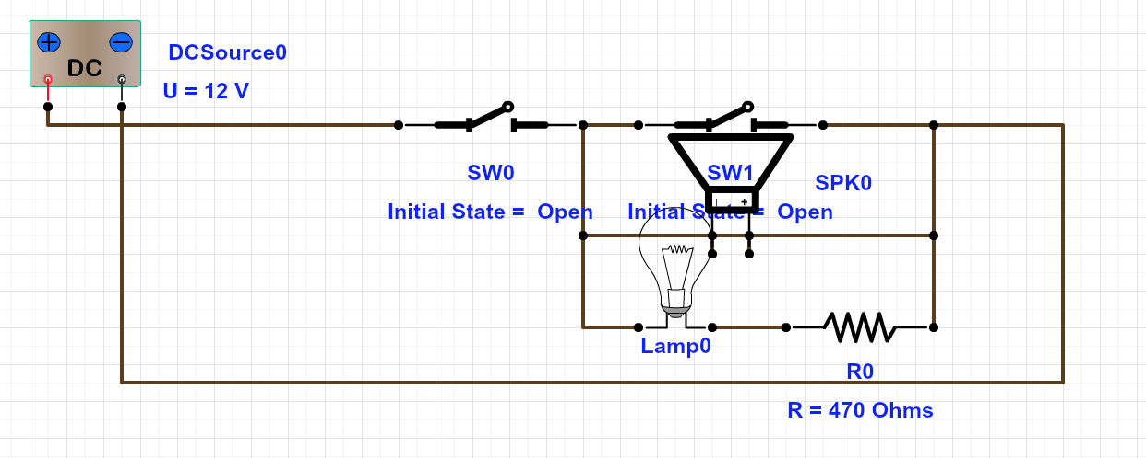

**Figure 1: Original Schematic of the Launcher System**

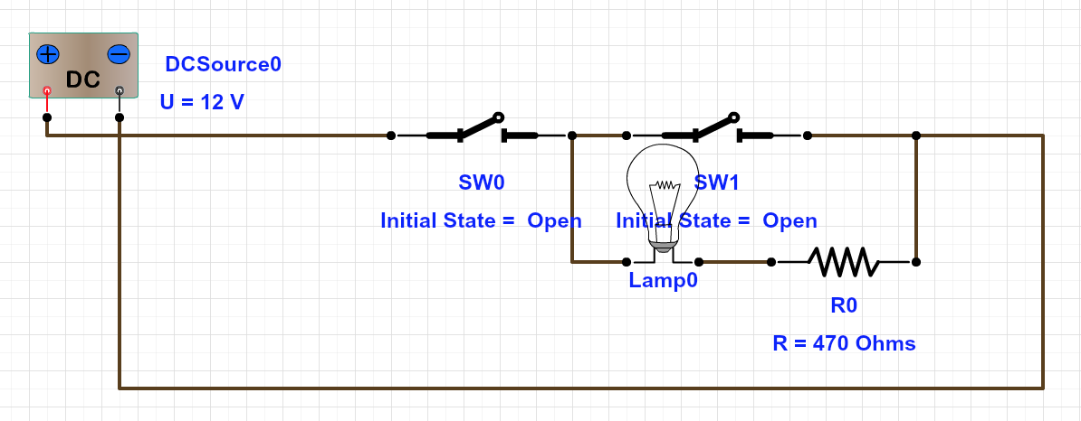

**Figure 2: Final Schematic of the Launcher System**

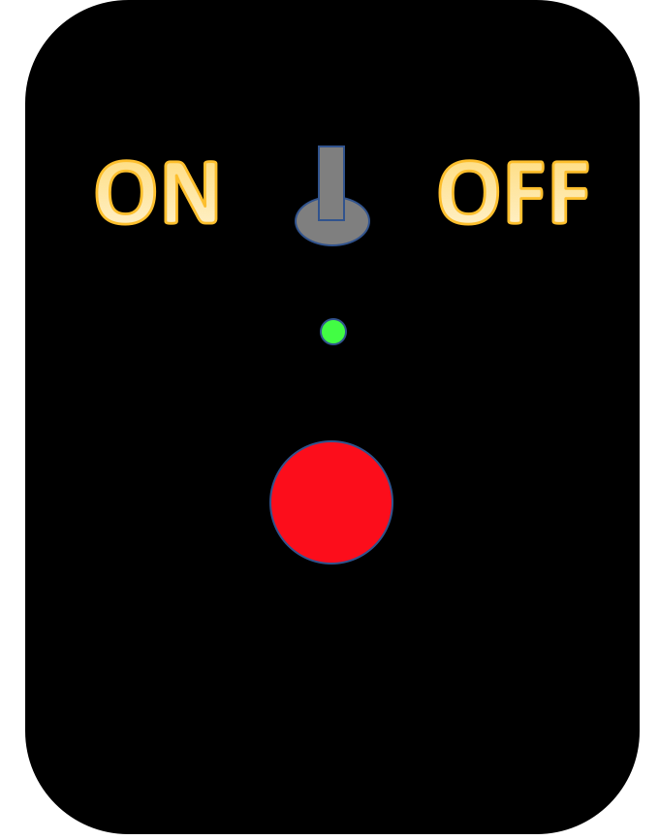

**Figure 3: Box of the Launcher System**

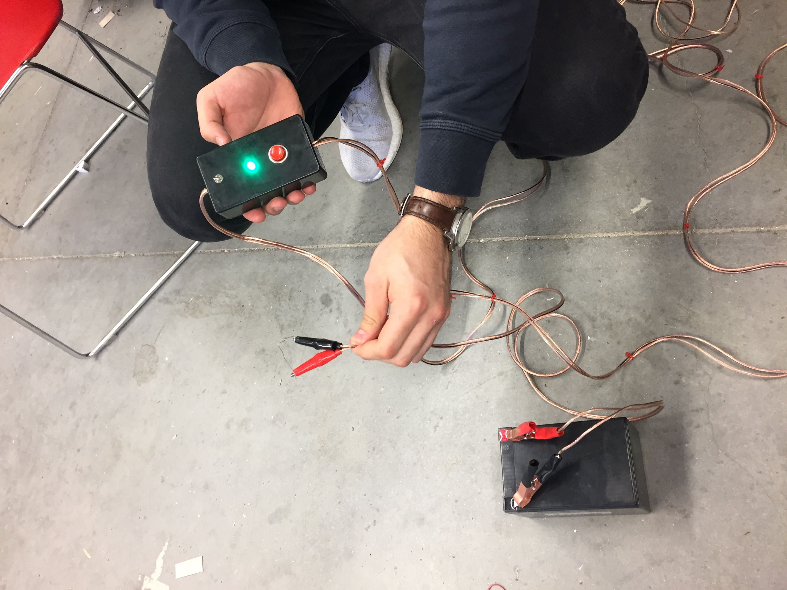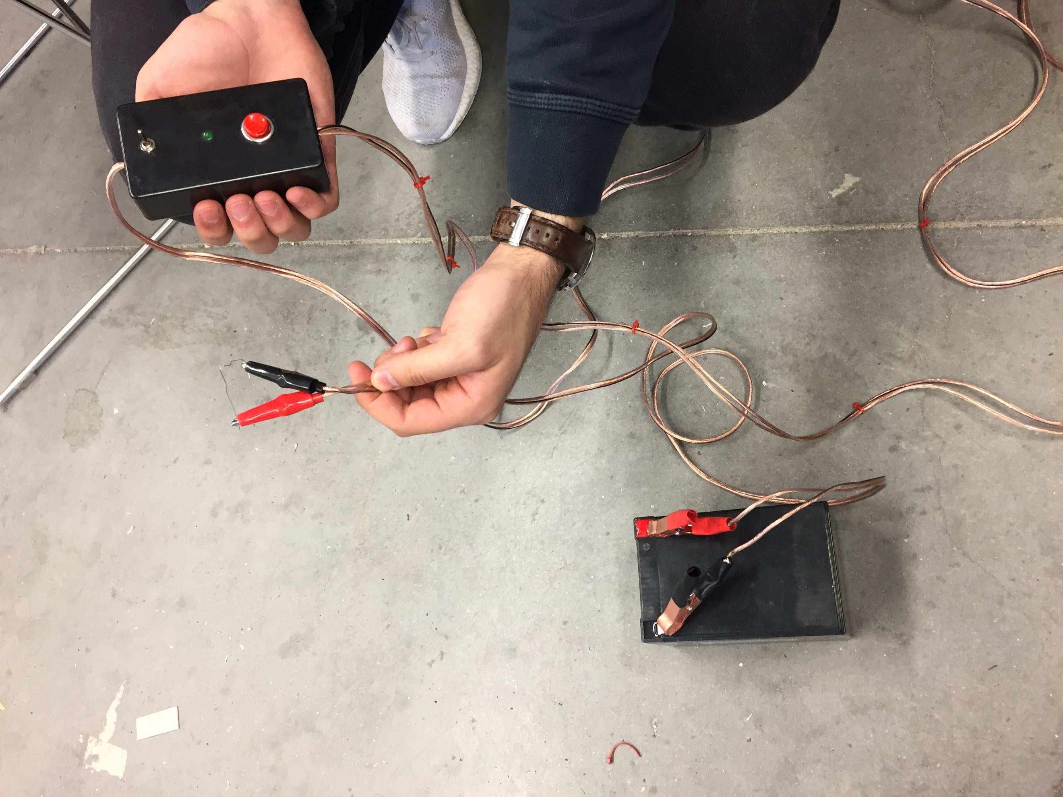

**Figure 5: Launcher when Turned on**

**Figure 4: Launcher when Turned off**

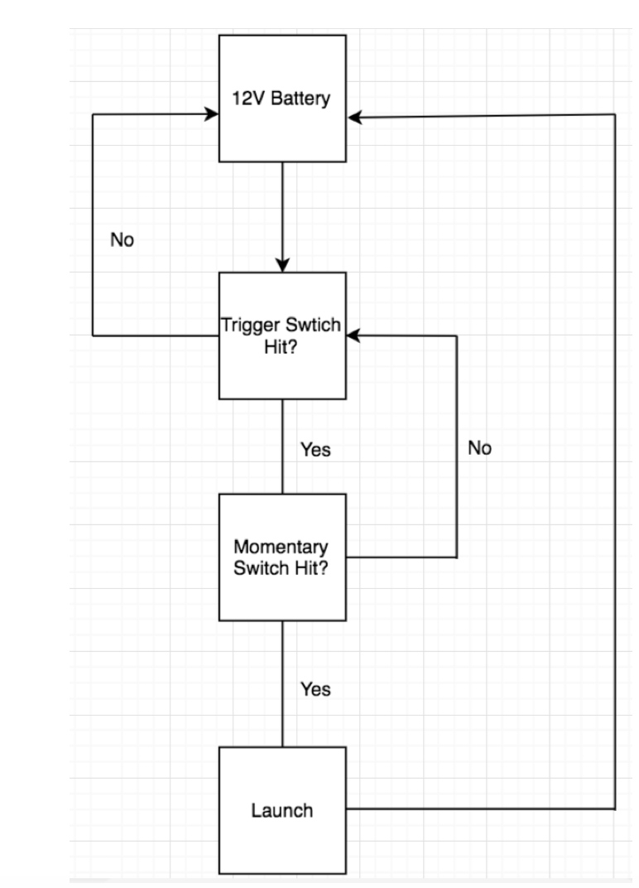

Toggle Switch on?

Launch Button Hit?

**Figure 6: Block Diagram of the Electrical Launcher System**

# Electrical Launcher Conclusions

Overall, the designing and construction of the launcher was smooth and no problems arose. The piezo buzzer was removed from the design because the sound was extremely loud. The idea of the design was inspired by information in Ref 1 in References. The circuit was built and tested in the lab. The circuit took 12 volts at the input and once the switch was turned on, as shown in Figure 5, the green LED turned on. The green LED proves that there is continuity in the circuit and is ready for the launch button to be pressed. Once the launch button was pressed, the voltage supply was displaying a current overload which was desired because about 6 amps of current is running through the circuit. After concluding that the circuit worked properly, the same circuit was built again to fit in the box used for the launcher. The soldering of the circuit and manufacturing of the box was straight forward and the launcher worked on the first try. The soldering of the circuit was done by me and the manufacturing of the box was done by Charlie Nitschelm since he has experience with drill presses. The drill press was used to cut the holes for the components on the box. It has been used multiple times in test flights for rockets made in the club. The launcher was designed and constructed quicker than proposed in the Gantt chart below and was done within the budget.

**Stabilization System**

General Description

The purpose of the stabilization system was to guide a rocket vertically after the initial liftoff of a rocket. The stabilization system has two main roles during the launch of a rocket; to provide stability of the rocket, and to control the rocket while it maneuvers vertically. Since the team decided to make the rocket smaller in diameter than originally planned, the team also decided to leave the stabilization system away from the competition and experiment on other sized rockets to ensure that the system works and is helpful in reaching a higher altitude for future competition. The rocket being tested on will be navigated vertically by using an Arduino Nano microcontroller that senses the position or orientation of the top of the rocket using an MPU6050 IMU (Inertial Measurement Unit) and changes its direction in the x and y axes with gimbal thrust. The microcontroller will receive the direction of the rocket from an IMU and will control the movement of servos that adjust the X and Y axis which control the direction of the engine, counteracting the movement of the top of the rocket. The closed feedback control loop system for the guidance system is illustrated in Figure 7 below. The IMU and Arduino was powered by an 11.1 volt lipo battery while the servos were powered by 4 AA batteries.

The IMU has accelerometers and gyroscopes embedded into one single unit that collects a body’s specific force and angular rate. The accelerometer is used to also detect orientation so this was utilized to determine the orientation during the flight of a rocket. The idea is to have the IMU tell the servo motors to angle the engine in the same direction the rocket is drifting to so that the force of the engine will create a torque moving the rocket back to vertical. This is illustrated in Figure 8. Doing this will allow the team to not have to figure out the movement of fins to counteract air flow.

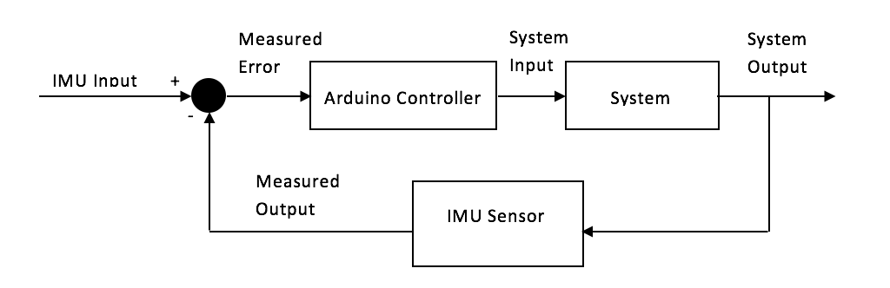

**Figure 7: System Diagram of the Guidance System - Closed-loop (feedback) Control**

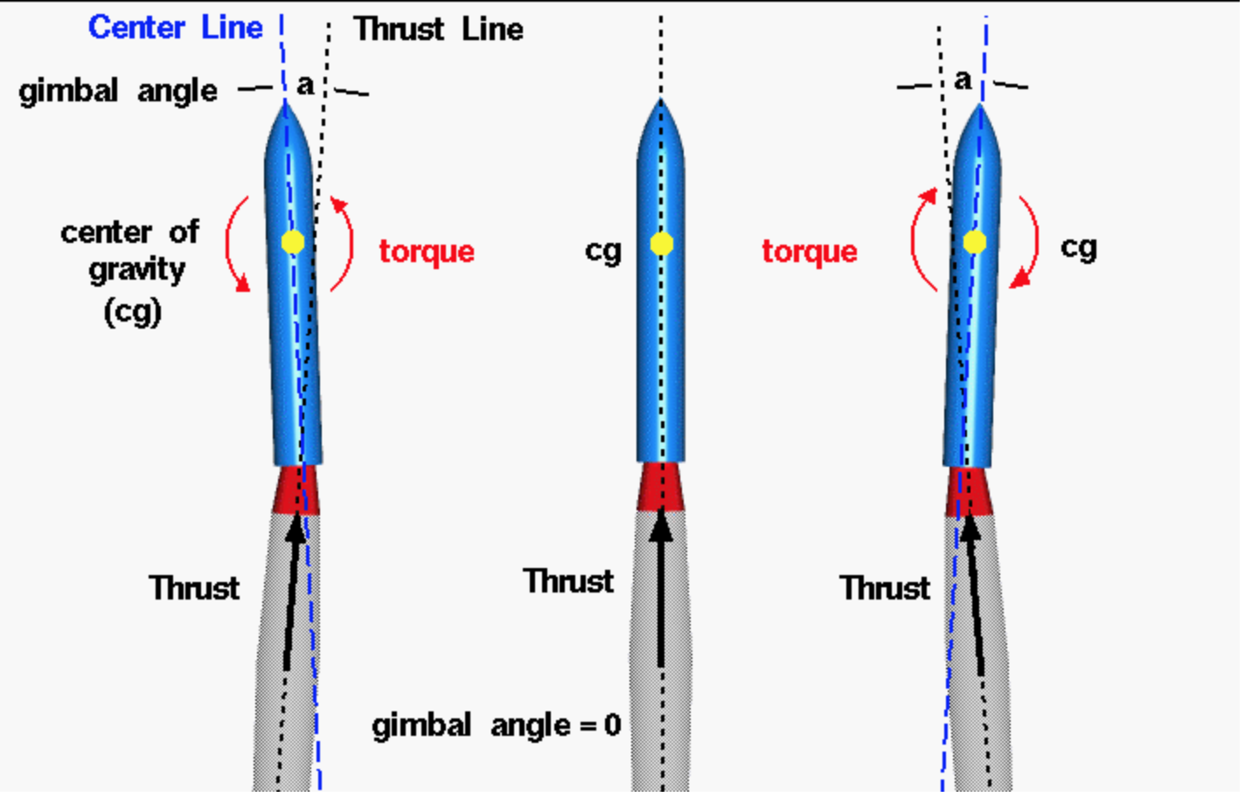

**Figure 8: Gimbaled Thrust of Rocket Engine**

Pinout Diagrams of the Stabilization System

Figures 9 and 10 show two different pinout diagrams for the system. Figure 9 shows the original pinout diagram with the MPU6050 powered by the 6-volt rail on the breadboard, and Figure 10 shows the updated pinout diagram with the sensor powered by the 5-volt and ground pins on the Nano. When 6 volts was inputted into the VCC pin on the IMU, the chip blew up because the data sheet was not checked before doing so. Another chip had to be ordered and it was determined that the sensor must be powered by the 5-volt pin on the Nano. The Nano is also powered by the 11.1-volt lipo battery because the operating voltage is 7-12 volts. Without the 11.1 volts, the sensor would not be able to get the full 5 volts going to its input.

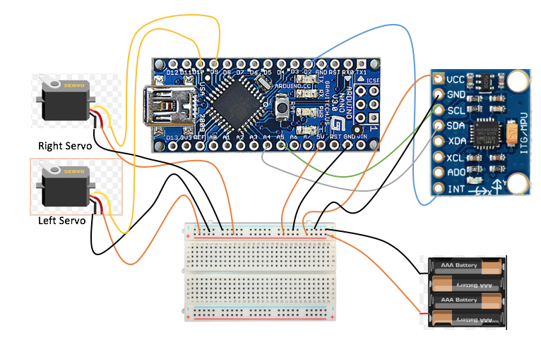

**Figure 9: Original Pinout Diagram with Nano**

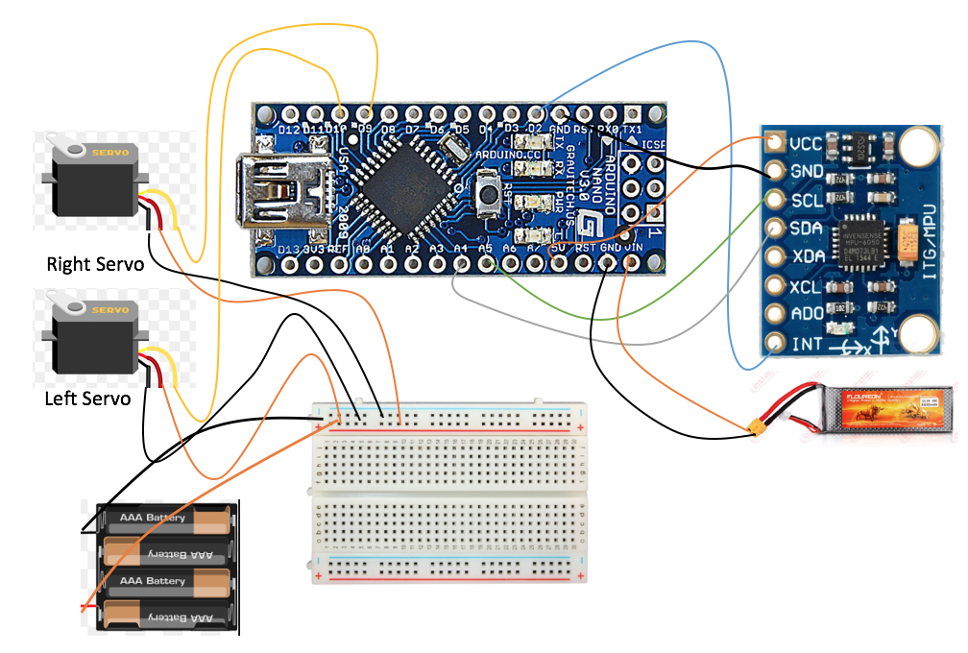

**Figure 10: Updated Pinout Diagram with Nano**

Assembly of the Stabilization System

The assembly of the stabilization system is illustrated in Figure 11 below. The PCB was used to create a rail for power from the battery pack to the servos, as well as house the Arduino to make connections from the MPU6050 and servos to the Arduino’s respective analog and digital pins. Using a PCB saved space on the chassis because all pins that aren’t used on it can be disposed. A chassis had to be created to hold all the electronics in place for the system and a SolidWorks model of this chassis is shown in Figure 12. This chassis was made from quarter inch clear acrylic. The x and y gimbals are also shown with the chassis. The physical assembly is shown in Figure 14. Figure 13 illustrates the gimbal assembly for the x and y axis. The team decided to use the engine holder for the X ring gimbal so that the system is reloadable. The rings for the x and y gimbals were manufactured by Charlie Nitschelm on the mechanical side of the project and the arms from the servos to the rings were attached by the ECE side of the project.

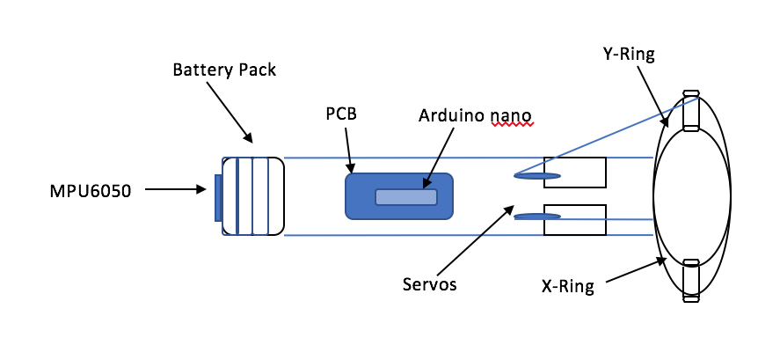

**Figure 11: Assembly of the Stabilization System**

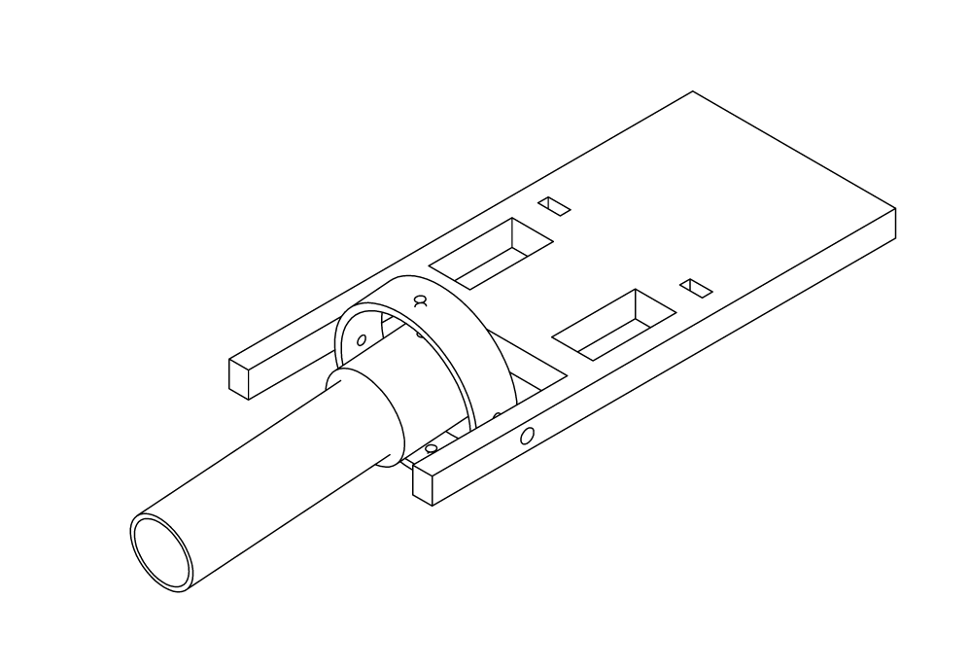

**Figure 12: Chassis of the Stabilization System**

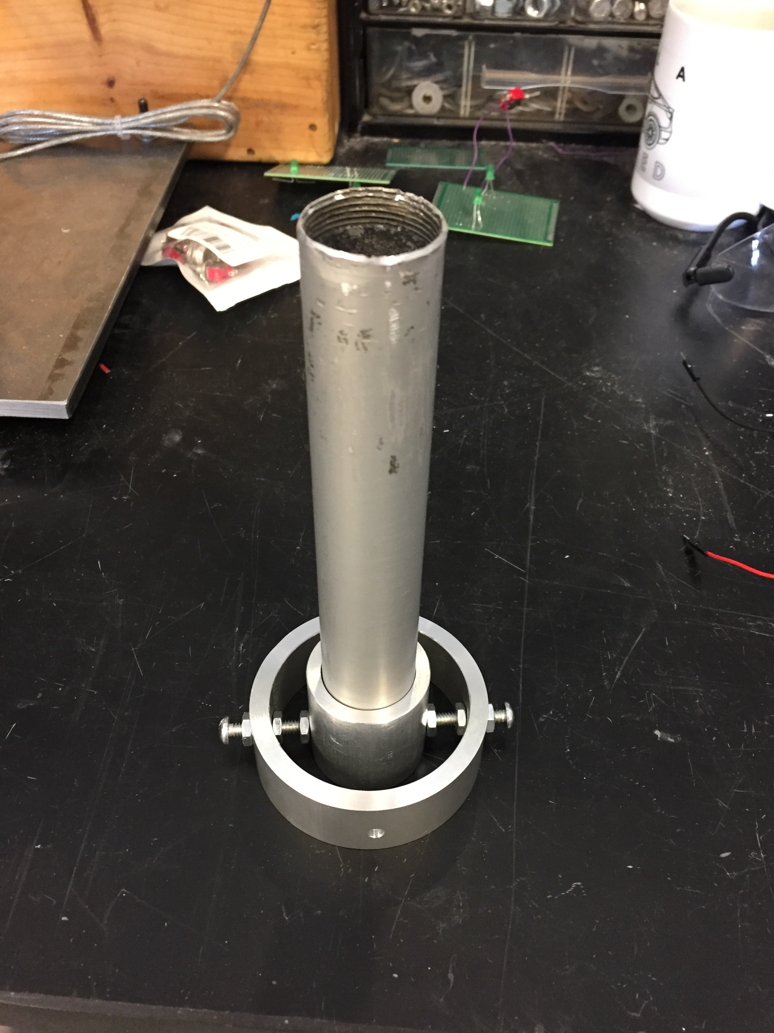

**Figure 13: X and Y Gimbal with Engine Holder**

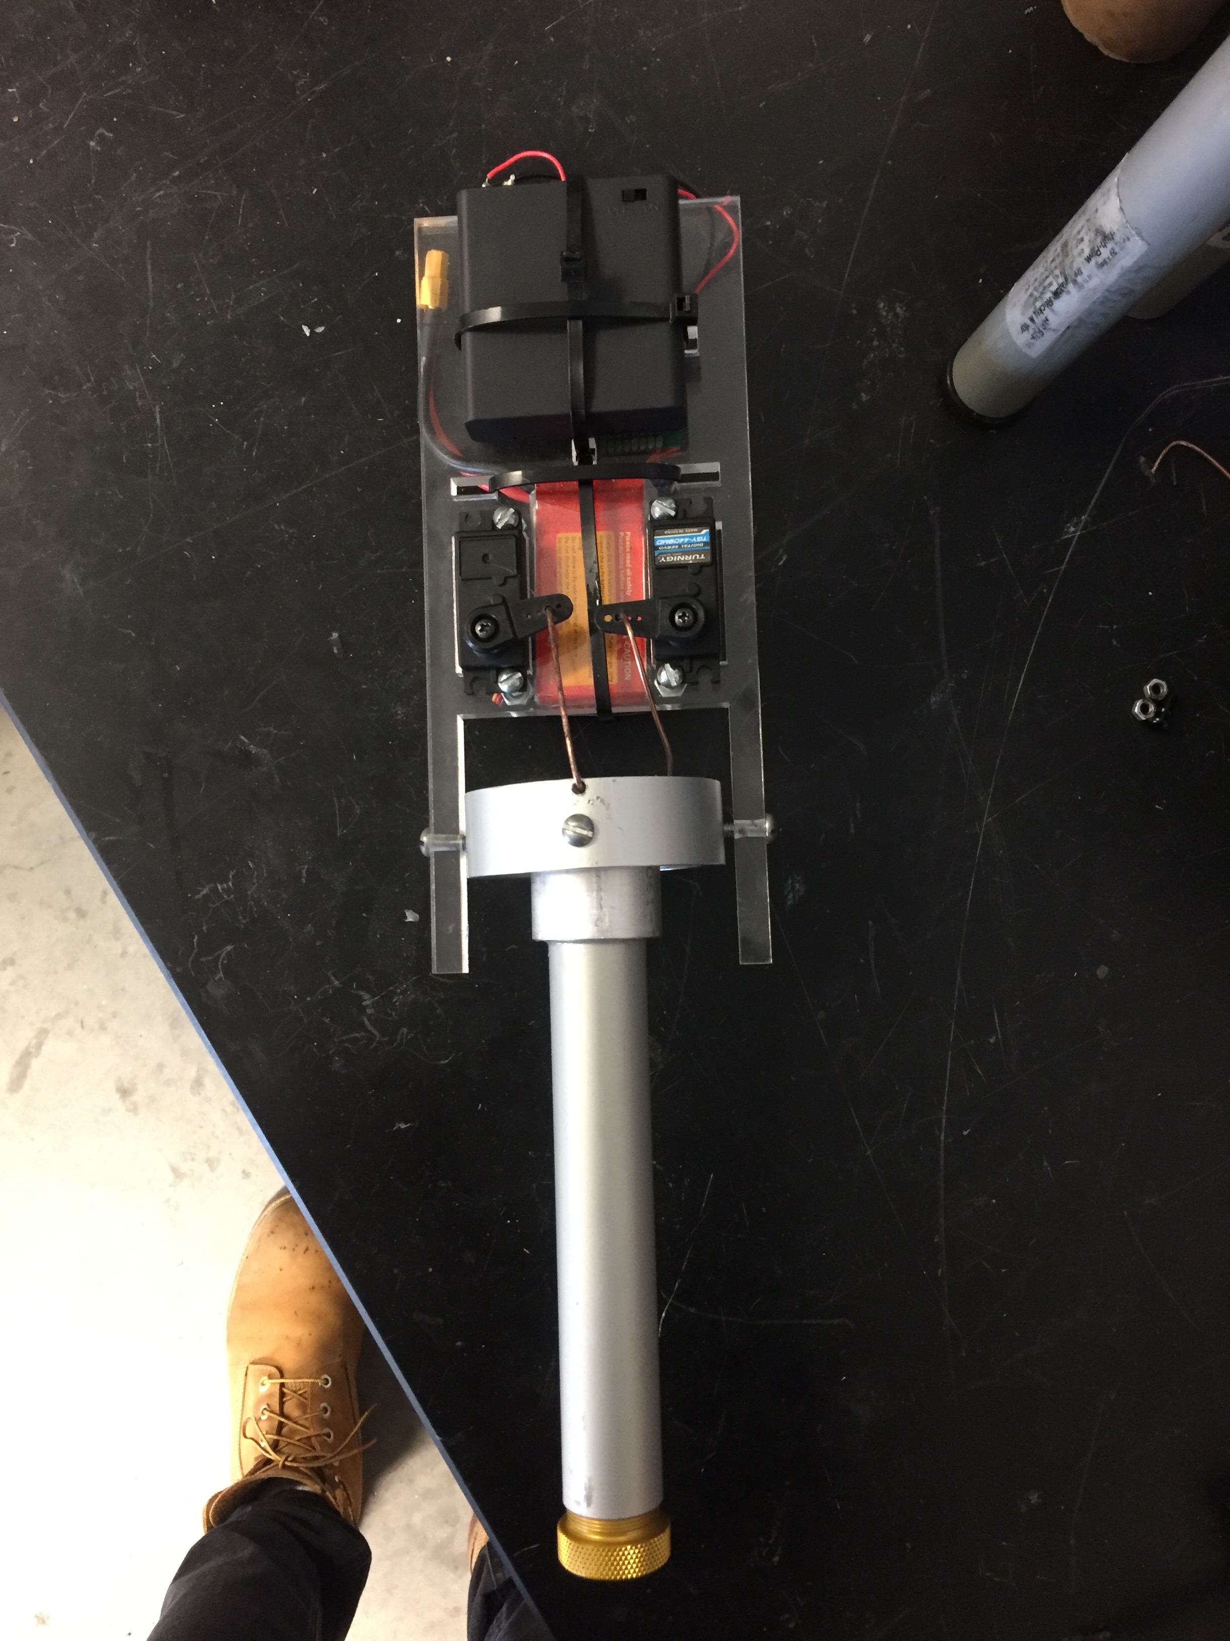

**Figure 14: Physical Assembly of the Stabilization System**

Stabilization System Conclusions

The stabilization system was the most important and tedious part of this project. There were plenty of aspects that were good and bad with this system. To start with the bad, the servo motors that were originally bought, the Rioband MG995 servos, were not functioning the way that they were supposed to. The y ring servo was rotating past 180 degrees which is not specified in its data sheet. The servos were returned and a new pair was ordered. As mentioned above, the first MPU6050 that was ordered was blown up because the 6-volt rail from the battery pack was used to power it. Fortunately, this didn’t cause any time issues as the chassis hasn’t been built yet. To start this project, an Arduino Uno was proposed to be used, but after considering other options, a Nano was decided to be used because it has all the same functions as an Uno. The Nano is also smaller and the pins are made to be soldered. Lastly, the coding for the system was made so that the servos move in the same direction as the sensors orientation. The code was influenced from the project in Ref 7 in the References section. After many hours of researching the commands for the IMU sensor, the code was reduced and some commands were changed to better fit the project. If the commands for the IMU were found earlier, the code would’ve been adjusted much quicker and saved some time, but once the commands were found, the code was easy to adjust. Now for the good aspects, the team decided late in the project that the x ring should be replaced with the engine holder so that engines can be replaced with every flight efficiently without having to epoxy an engine onto the x ring gimbal every time. The decision to use the Nano instead of the Uno also helped the with the assembly of the system because the pins were made to be soldered unlike the Uno. The Nano also operates with a 16 kHz clock which makes the reaction of the servos from the IMU extremely quick, which is necessary during the flight of the rocket. The test of the system took place after the URC just in case something could’ve went wrong if the system was tested before the event. A tether test was setup and is illustrated in Figure 15 below. Kevlar was used to attach the rocket to the aluminum poles and the poles were reinforced in the ground with heavy stones. The tests didn’t go as planned because there was an issue with the engine. The igniter seemed to be too thick because it never popped out of the engine, causing a pressure to build up which didn’t ignite the engine. Because of the price, and time it takes to order a new engine, this was the only test that took place for the system.

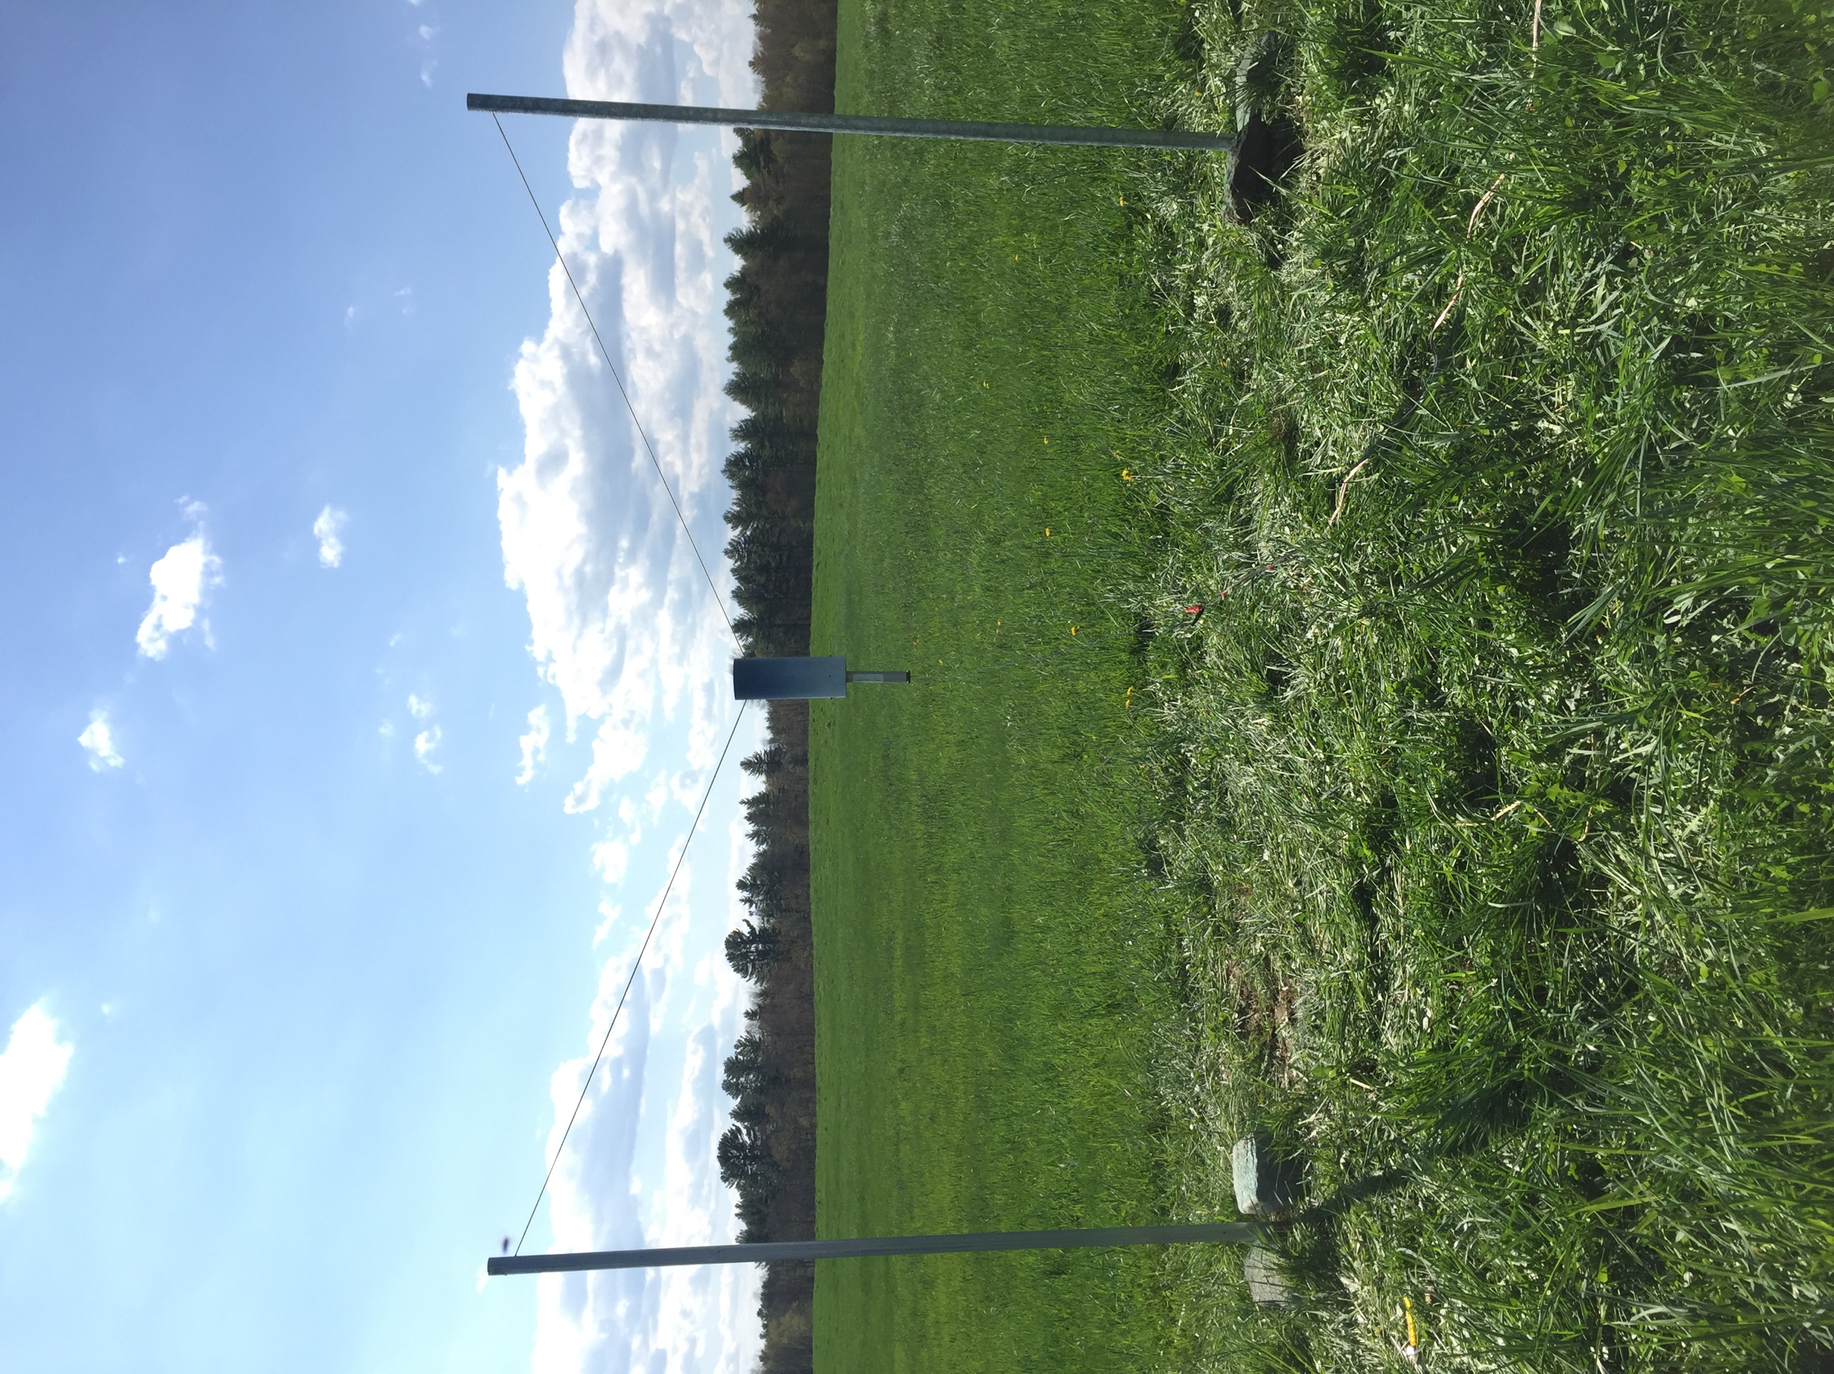

**Figure 15: Tether Test for Stabilization System**

**Parachute Deployment (Dual Deployment)**

General Description

Dual deployment generally means that two parachutes are ejected out of a high-power rocket to land safely. The first parachute is ejected at apogee (drogue) and the other is deployed at the rockets decent, which is typically 500-700 feet with a full-sized parachute (main). The advantage of deploying two parachutes is that the rocket falls fast for most of the decent and doesn’t drift far from the launch site. The way the system in the rocket will work is the electronics bay will sense the altitude using a TeleMega Altimeter and send two electrical ejection charges at the appropriate times. The altimeter calculates the rockets ascent into the air using a barometer and senses when it has reached apogee. The electronic brain sends electricity to the first igniter which sets off a small charge of black powder. Doing so pressurizes a section of the rocket and ejects a parachute. Since the drogue chute is bringing the rocket down quickly, the electronics bay is still calculating the altitude of the rocket and it will then trigger a second electrical burst to the main chute igniter at 500 feet (or whatever height the team finds necessary). Figure 16 shows the configuration of the dual-deployment process.

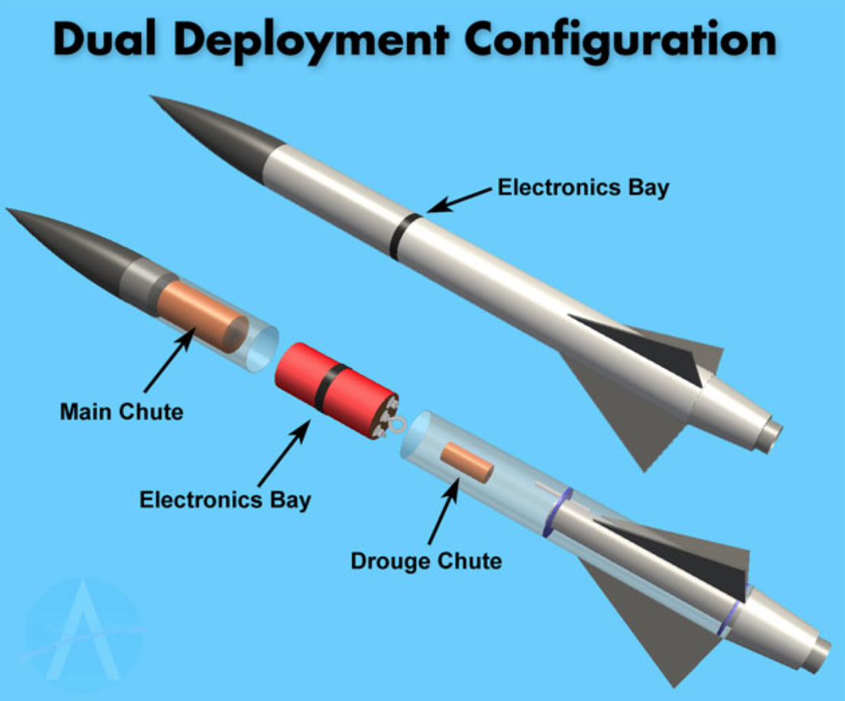

**Figure 16: Dual Deployment Configuration**

Parachute Deployment Conclusions

Parachute deployment was the most difficult part of the project for the team. It was a mystery all year figuring out what electronics to use and how the pieces were going to work together. Originally, using an accelerometer with a mini servo and Arduino was proposed to be used to do the deployments, but in the end, it was in the team’s best interest to use the TeleMega altimeter since it can operate for dual-deployments as well as provide GPS tracking so that the rocket can be retrieved if there are any issues with the deployments or drifts. The team did lose a rocket during a test flight with the RRC3 altimeter that was originally bought for parachute deployment. One of the strings of Kevlar sheered from the rocket between the nose cose and electronics bay causing the electronics bay to go missing in the woods. This happened a week before the URC so the team had to spend a fortune to expedite shipping of the TeleMega altimeter as well as the blue tube that was used to create the two-stage rocket. In the long run, this altimeter will save the team money because the GPS will assure that the team will retrieve the rocket after flight if something may go wrong. The altimeter was purchased and it was utilized and tested quickly to make sure it functions correctly. An electronics bay was created for the altimeter to keep it safe and snug in the rocket. The system is shown in Figure 17 and the manufactured electronics bay is shown in Figure 18 below. The drogue igniter feeds into a little tube that’s filled with black powder and ignites the powder when the rocket reaches apogee. This creates pressure which shoots the back end of the rocket off which deploys the drogue parachute. The same procedure occurs once the rocket reaches 500 feet and deploys the main chute from the nose cone. Deploying at this altitude will make sure the rocket doesn’t drift as far. During the team’s first test run with the TeleMega however, there was too much black powder loaded for the drogue chute that when the rocket reached apogee, the back end of the rocket and the nose cone shot off causing a preemptive main deploy at approximately 850 meters. This caused the rocket to drift heavily, but was retrieved from the GPS unit on the altimeter. This data is shown in Figure 19.

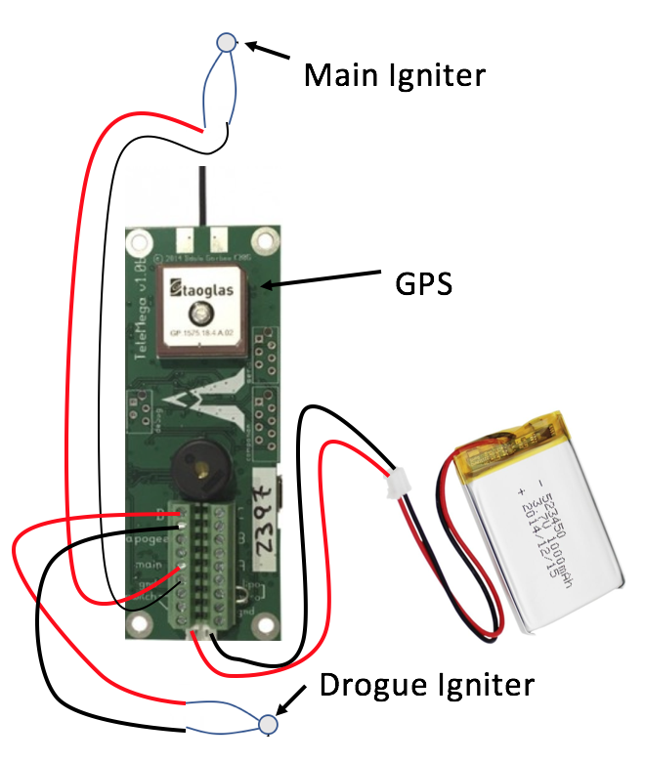

**Figure 17: TeleMega Altimeter with Igniter Attachments**

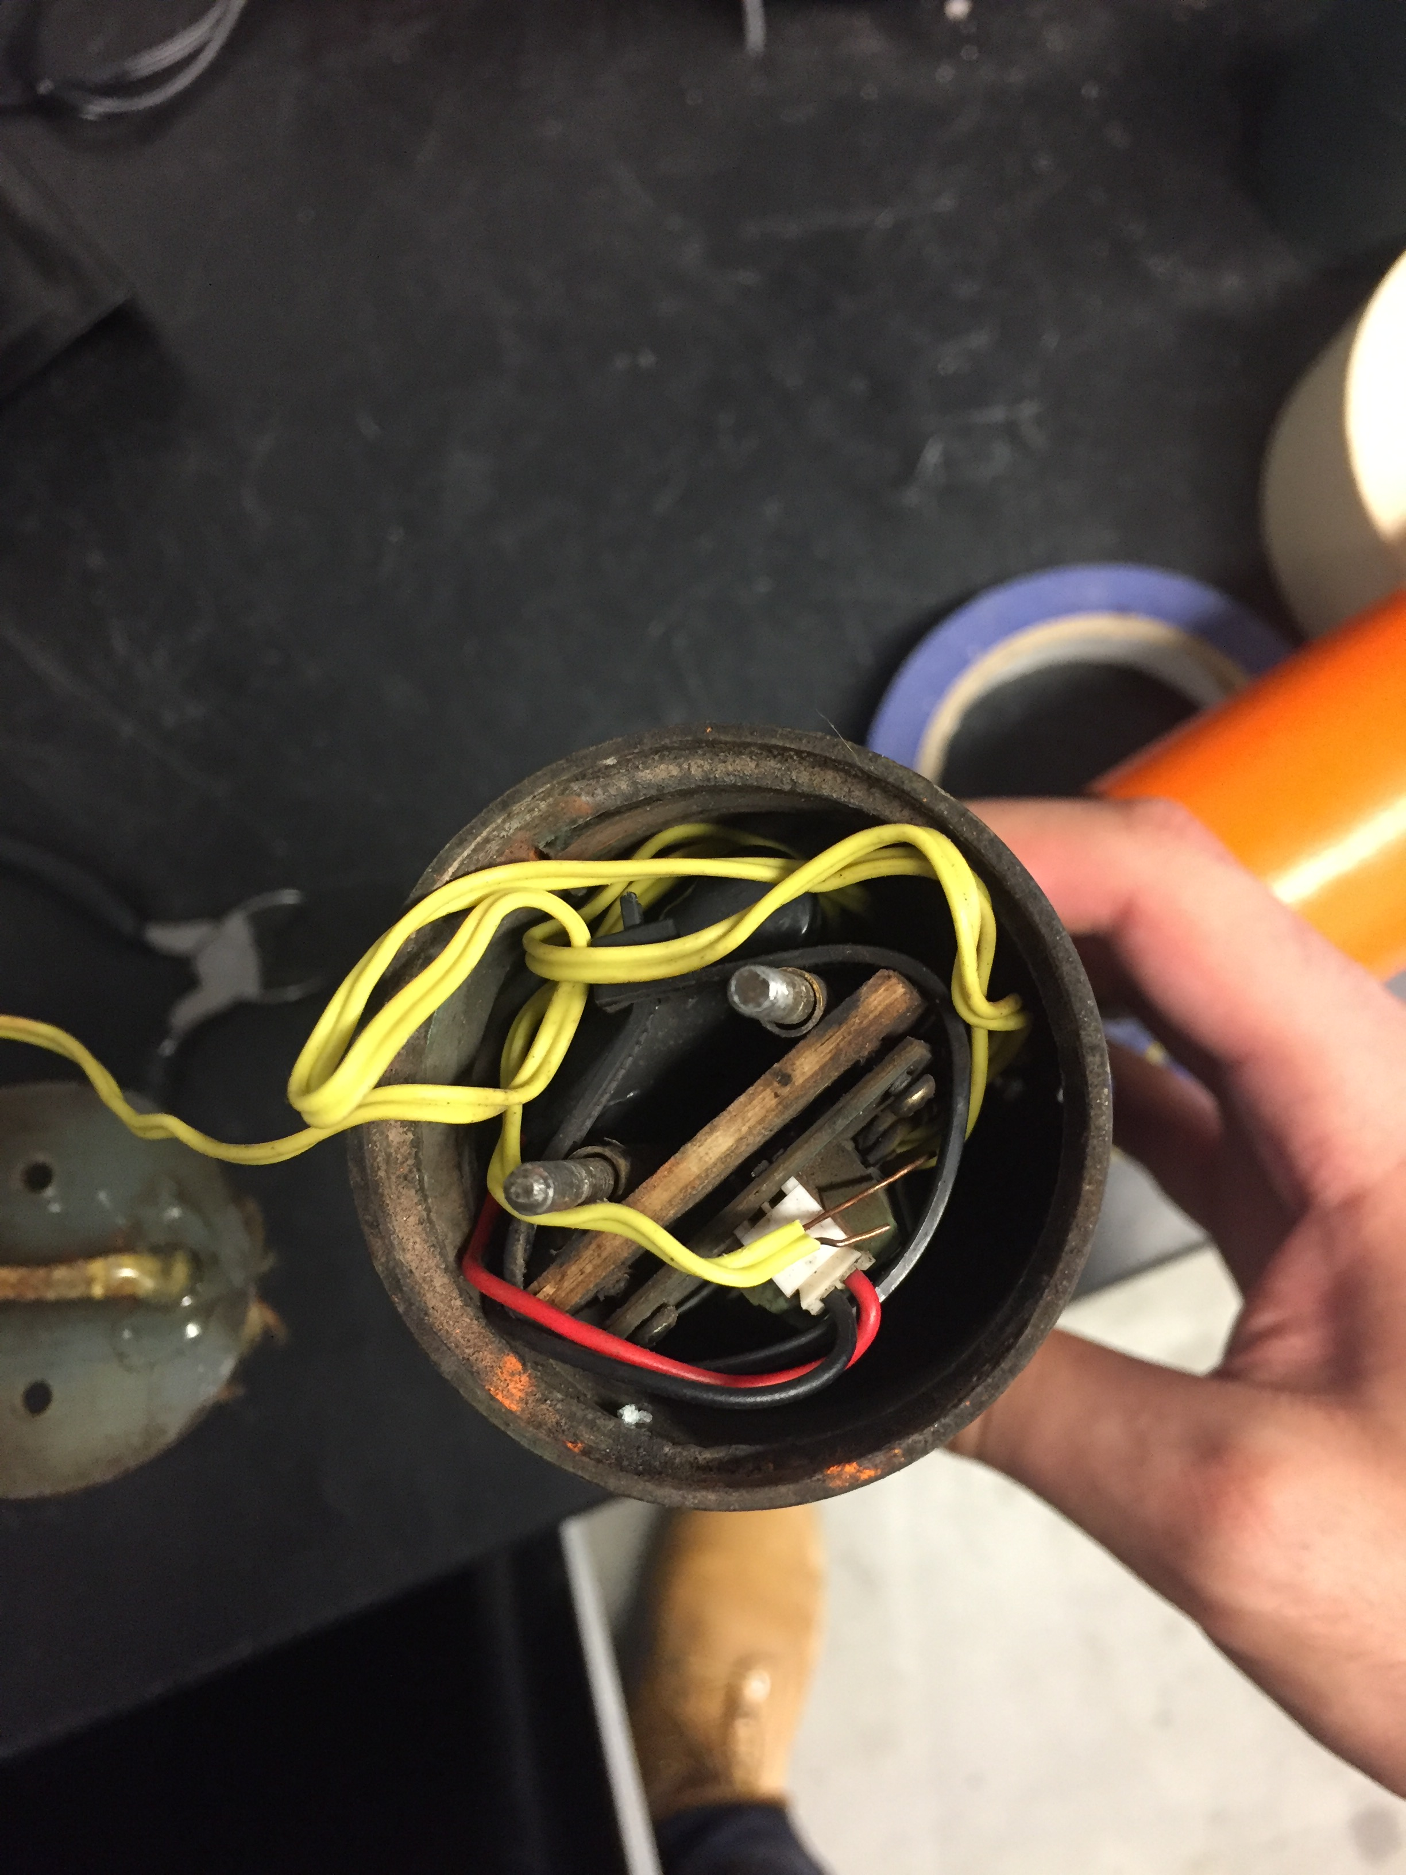

**Figure 18: TeleMega Altimeter Electronics Bay**

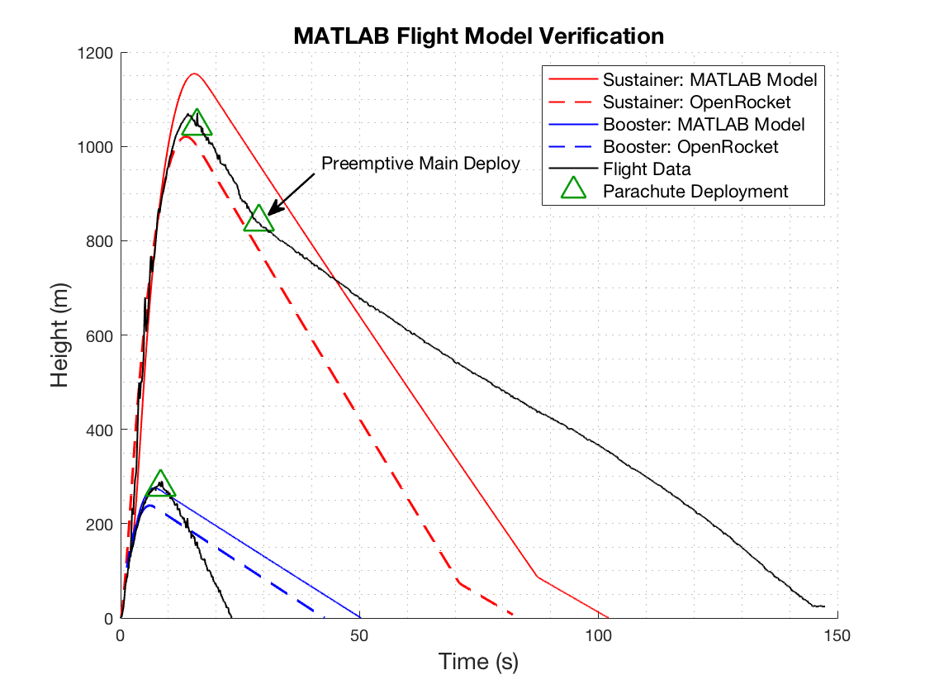

**Figure 19: Data Extracted from RRC3 Altimeter**

**Original Budget**

|  |  |  |
| --- | --- | --- |
| **Budget Item** | **Cost** | **Item Purpose** |
| Arduino Uno | $21.49 | Microcontroller for the guidance system. |
| Standard Size - High Torque - Metal Gear Servo x2 | $39.90 | Control the X and Y axis. |
| 10 DOF IMU Sensor (C) Inertial Measurement Unit | 21.99 | Senses the direction of the top of the rocket and tells the Arduino so that the servos control the X and X axes. |
| 50-ft 16 Gauge Copper Wire | $8 | To be used for the electrical launcher. |
| Trigger Switch | $15 | When pressed, the launcher then waits for the safety button (red button) to be pushed. |
| Safety Momentary Push Button Switch | $5 | When pushed, the circuit is closed and current ignites the rocket. |
| Ignitors | $6 | The ignitor is lit once the circuit is closed starting the motor of the rocket. |
| Piezo Tone Buzzer | $3 | Sounds when the trigger switch is pushed. |
| BMP180 Barometric Pressure/Temperature/Altitude Sensor- 5V ready | $9.95 | Sensor that senses air pressure and senses when the rocket reaches apogee. |
| SunFounder Digital Accelerometer ADXL345 Module for Arduino and Raspberry Pi | $7 | Senses when the velocity hits 0 m/s thus assuming apogee. |
| Parachute | $5 | To make sure the rocket lands safely on the ground. |
| Physical Launchpad made from PVC Piping and Blast Pads | $40 | This will be used to keep the rocket in place before lift-off. |
| **Total:** | **180.33** | **This project will also be looking for sponsorship from more than companies.** |

**Table 2: Rough Estimated Cost of each Item**

**Revised Budget**

|  |  |  |
| --- | --- | --- |
| **Budget Item** | **Cost** | **Item Purpose** |
| Arduino Uno and Nano | $44.00 | Microcontroller for the stabilization system. |
| Turnigy TGY-4409MD Metal Gear Digital Servo | $37.56 | Control the x and y gimbals of stabilization system. |
| MPU6050 6 Axis Gyroscope Module | $5.09 | Senses the direction of the top of the rocket and tells the Arduino so that the servos control the x and y axes. |
| Floureon 2 Pack 11.1V Lipo Batteries | $23.99 | Powers the Arduino and MPU6050 for the stabilization system. |
| Paxoco 17-Piece PCB Boards | $8.99 | Used to house the Arduino and voltage rail for the servos. |
| Jumper Wires | $4.99 | Used to connect all parts of stabilization system during testing. |
| 50-ft 16 Gauge Copper Wire | $10.99 | To be used for the electrical launcher. |
| Normal Open Momentary Push Button Switch | $4.88 | When pressed, the launcher will ignite the electric ignitors, thus launching the rocket. |
| Hammond 1591BSBK ABS Project Box Black | $6.51 | Box that holds the circuit of the launcher. |
| Safety Toggle Switch | $7.89 | When placed in the on position, the current runs through the LED, buzzer, and resistor. |
| Igniters | $6 | The igniter is lit once the circuit is closed. This starts the motor of the rocket. |
| RadioShack 76dB Piezo Buzzer x 2 | $5.99 | Sounds when the trigger switch is pushed. |
| ExpertPower EXP12120 12 Volt 12 Amp Rechargeable battery | $25.99 | Supplies power to the Electrical Launcher System. |
| RadioShack 5mm Green LED x 100 | $6.36 | Lights up when toggle switch is in the ON position and pushbutton is not hit. |
| SunFounder Digital Accelerometer ADXL345 Module for Arduino and Raspberry Pi | $7 | Senses when the velocity hits 0 m/s thus assuming apogee. |
| RRC3 Altimeter | $71.95 | Altimeter that is used for dual deployment of the parachutes. |
| **Total:** | **$278.18** | **Companies have also supplied us with equipment and materials and the Parents Association has donated $4000 for the project.** |

**Table 3: Revised Budget**

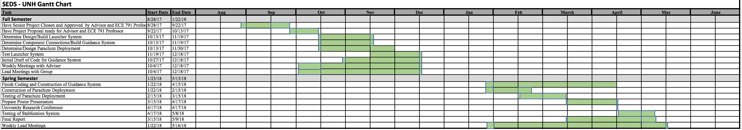**Gantt Chart**

**Table 4: Gantt Chart for the Project**

**Ethical Consideration**

After researching all electrical components for this project and thinking about what I could contribute to the rocket, I wanted to make sure that if I used anything as a reference, that I put my own personal touch on it. For example, when I researched the stabilization system for the rocket, I thought the idea of controlling gimbal thrust was a great idea because it was simpler than fin controlling. The system I found online looked good, but I saw flaws in the design. The system found online uses an Arduino Uno, and to load an engine onto the system, an engine must be epoxied on every time. My idea to improve these parts of the design was to use an Arduino Nano since it has the same function as an Uno, and to replace the x-ring gimbal with the engine holder so that one could load an engine into the system after every flight. Because the Nano is much smaller in length than the Uno, the chassis was reduced in size and the system became lighter. The code was changed a little bit to best fit the function of the servos. The original code used some gyroscope functions, but those were removed because the accelerometer was used in the design. I also decided to use clear acrylic to make the system look more professional and clean. I feel as though I made this idea better and added some great personal touches to it.

Everything that was done with the launcher was researched in Ref 1. The circuit was designed to fit my own specifications, but the idea was influenced by reading the “BUILDING YOUR OWN LAUNCH SYSTEM AND LAUNCH PAD” article. The box design was from my vision, as well as how to power the launcher. Since this part of the project was much simpler than the stabilization system and parachute deployment, there wasn’t much research done with it and all or most of the ideas were from me.

Parachute deployment was mainly influenced from the “Make: High Power Rockets” book in Ref 8. This showed a simple design on how to dual deploy. A coupler and electronics bay was built for the altimeter which was made from wood and cardboard cylinders. The team also decided to use a switch which arms the altimeter before flight. A string is attached to the switch and is pulled to turn on the device. Parachute deployment was heavily influenced from the book, but personal touches were added to the design.

**Safety**

Safety precautions were taken throughout the whole project. When creating a launcher, there is a deadly amount of current at the output so the team was always thinking about safety first before pushing the launch button. When the gator clips at the output were hooked onto the igniters, it was suggested that the team member at the output side hold onto the wire or the rubber on the clips since those are both insulators. Another precaution the team took was to never hook the leads at the output and push the launch button because that could cause an overload of current on the supply thus damaging the circuit. The team also used a drill press to drill the holes for the components of the launcher. Charlie Nitschelm took over this project because he had experience with a drill press before and had authorization to access the ME workshop. During test launches with rockets, the team stood 30 ft. away from the rocket to ensure the safety of the team.

During the testing of the stabilization system, the team had to make sure that the tether test wouldn’t allow the system to shear off the Kevlar. Kevlar was used because it can hold a substantial amount of weight without ripping. The aluminum poles were used because they are more stable and have a lower chance of breaking than wooden poles. The poles were staked to the ground and heavy stones were used to reinforce the poles in the ground. Even though the system never launched due to engine failure, the test would’ve been safe to implement because of the materials used.

For parachute deployment, the team took safety precautions to make sure the electronics bay kept all electronics in the rocket free from harm. The TeleMega altimeter has a great feature where an igniter can be inputted into the main or drogue ports to test and see if the altimeter is supplying enough current to flame the igniters. This was done before every test run to make sure the rocket was going to descend safely. The igniters were placed in small plastic tubes to make sure that the ignition of the black powder was contained and not open in the rocket.

**Standards Utilized**

The only standards that were considered for this project were the NAR safety code rules. These rules were used as a baseline to make sure that the launcher that was constructed was safe to use. The most important aspect of this project is safety, and these rules ensure everyone’s safety during each launch of a rocket. The launcher was designed with a safety switch so that if the launch button was pushed on accident, nothing would happen. The electrical wire that was used was 30 ft. long because the engine motor being used has a grade higher than D. The safety code states that the team must be 30 ft. away if the engine motor is larger than a D grade. The rocket will also be launched within 30 degrees of the vertical to ensure that the rocket flies nearly straight up, and the team will use a blast deflector to prevent the motor's exhaust from hitting the ground. These are the only standards that were utilized for this project.

**Contributions of Each Group Member**

**Matt Dodge (Freshman):** Matt was a key contributor in the designing of the stabilization system on SolidWorks. Matt had experience beforehand with the software, which is great to see for a young EE. The SolidWorks files were helpful because it brought the stabilization system to life. The team got to see what the end product was going to look like. Matt was extremely helpful whenever he assisted with what the team was working on.

**Pedro Campos (Junior):** Pedro contributed to all soldering projects because of the experience he’s had with soldering and PCB boards. Pedro soldered the connections from the sensor to the Arduino, as well as created the voltage rail for the servos on the PCB. He also lent a hand whenever he could with the construction of the launcher. Pedro was in the lab with me whenever I needed help setting up tests for the launcher and was a great help throughout the whole project.

**Kristian Comer (Freshman):** Kristen is a CS major and was extremely helpful in assisting me with the code for the stabilization system. He helped me understand what was going on in the code so that I could make it more compact and better. Kristian attended all weekly meetings and made an effort to help with electrical aspects of the project even though he specializes in CS.

**Daniel Nemr (Senior):** I brought the ideas to the table for the team and scheduled weekly meetings to get everything done. For the launcher, I came up with the design of the circuit, soldered all the components together in the box, and put the whole system together. I also tested the launcher on engine igniters that were ordered from Amazon. For the stabilization system, I found the idea online and thought about how the team could make the idea better. I decided that we should use the engine holder instead of the X ring so that the system is reloadable. The Arduino Nano was much more compact and had the same function as the Uno making the system lighter. The code was adjusted to look more organized, which was done by removing unwanted functions and adding ones that were necessary. The stabilization system is fully assembled and the team will be conducting a tether test on it to see if the gimbal thrust will adjust the direction of the rocket. For the parachute deployment, I assisted in the research about how dual-deployment can be done, and the best way to accomplish this was to use a TeleMega Altimeter which contains a barometer and GPS. I helped put the electronics bay together along with Charlie Nitschelm to keep the altimeter safe as well as dissected the user interface to understand how the altimeter works.

**Conclusions**

Overall, the project progressed at the rate it was proposed at. All objectives on the Gantt chart for the fall semester were completed and the work for the spring semester concluded successfully. All projects on the electrical side were completed before the semester ended and the MEs worked tirelessly to get their projects done as well. The team can make conclusions on the end results of all projects that were done during the first year of the club.

The electrical launcher was tested multiple times with igniters and for test launches. The team used the launcher in test flights of rockets that were made in the club, and it has worked perfectly. It ignites the pyrogen that is at the end of the igniter and sparks the engine causing the rocket to shoot up in the air. The designing, testing and construction of the launcher were quite simple and the end results show that there were no problems with this part of the project.

The stabilization system has been fully assembled and a tether test was setup so that testing could be done. Due to an engine failure however, there were no conclusions from the test. The budget for SEDS started to run low and the team decided to save some money for next semester. The delivery time for the engines is also long so by the time another engine arrived, conclusions wouldn’t have been able to be drawn before the final report was due. The team will continue testing this system over the summer break so that improvements can be proposed and implemented for next semester.

Parachute deployment has been tested multiple times on different rockets, and it has proven that it works. There was one test run where the rocket drifted too far and the rocket went missing, thus losing the RRC3 altimeter. The TeleMega altimeter has proven that it works and all rockets can now be retrieved after launches since the GPS can track the rocket. This altimeter will be used on the rocket that is being entered this year’s USRC competition and the design will most likely be utilized or improved upon for years to come. The design of the system took a while to figure out, but the team is happy with the end result because of how effective it is during test flights.

**Recommendations for Future Effort**

Since the USRC happens every year, there is always room for improvement. If the stabilization system proves to stabilize the rocket as well as help the rocket go higher in altitude, then the students that take part in this competition next year can design and construct a stabilization system that can fit in whatever diameter rocket the team decides to use. This aspect of the project served more as research than a component for this year’s project. The team wanted to see if this system helps the rocket stay stable in the air and go higher. The gimbals servo motors, and chassis specifically can be adjusted to comply with whatever sized rocket engine is used.

The launcher can be improved by using a larger switch as well as black and red wire. Going into the project the team didn’t have much money to spend on supplies, but once the spring semester started the team got news that the Parents Association funded the team $4,000 which was huge. If this money was at our disposal in the beginning of the project, I believe it would’ve been beneficial to spend the extra money to buy the different colored wire to distinguish positive and ground from the 12-volt battery supply. The copper transparent wire was purchased because it was cheap and came with 50 ft. of it and the switch was purchased because of the same reasons.

My recommendation for parachute deployment is to definitely do more reading on how dual-deployment is done. After countless research online on how to deploy a parachute at apogee, there was never really a solid idea on how to do this, but once spring semester began, the lead of the SEDS club, Charlie Nitschelm, handed me a book on high-power rocketry and it helped give ideas on how to dual deploy. My recommendation is to not rely heavily on the internet when there are books that are written exclusively for high-power rocketry. After reading the book, the group decided to use a TeleMega altimeter that is used for dual deployment and GPS. The rocket must deploy a parachute at apogee (drogue) and one at 500 ft during its decent (main). This altimeter has ports on it that allows us to do so. If I knew about this device at the beginning of the project, it definitely would’ve saved a lot of time on researching and given me more time to execute the design and construction.

**References**

Ref 1. “BUILDING YOUR OWN LAUNCH SYSTEM AND LAUNCH PAD.” *Google Search*, Google,

Ref 2. Dougal, Evan, et al. *Digital Detection of Rocket Apogee*. Edited by Edward Luckett Luckett, 18 Dec. 2013.

Ref 3. “Closed Loop Systems.” *Electronics Tutorials*

Ref 4. “How Barometer (Pressure) Sensors Work.”

Ref 5. “A Beginner's Guide to Accelerometers.”

Ref 6. “How to Arduino #3 - Servos.” Garage Geek Guy, 19 Nov. 2013.

Ref 7. “Arduino Rocket Stabilization System [UD: 7/14/17].” *Hackaday.io*, ArsenioDev, 14 July 2017,

Ref 8. Westerfield, Mike. *Make: High-Power Rockets: Construction and Certification for Thousands of Feet and Beyond*. Maker Media, 2017.

Ref 9.I2Cdevlib: MPU6050 Class Reference, [www.i2cdevlib.com/docs/html/class_m_p_u6050.html](http://www.i2cdevlib.com/docs/html/class_m_p_u6050.html).

Ref 10. *NASA*, NASA, spaceflightsystems.grc.nasa.gov/education/rocket/gimbaled.html.

Ref 11. Edge, LLC. Engineers. “Bolt or Pin In Single Shear Equation and Calculator.” *Engineers Edge*

Ref 12. “INTRO TO DUAL DEPLOYMENT IN ROCKETRY.” *Apogee Components*.

**Appendices**

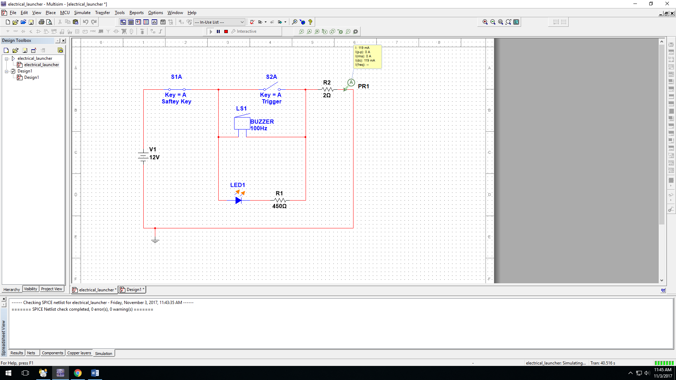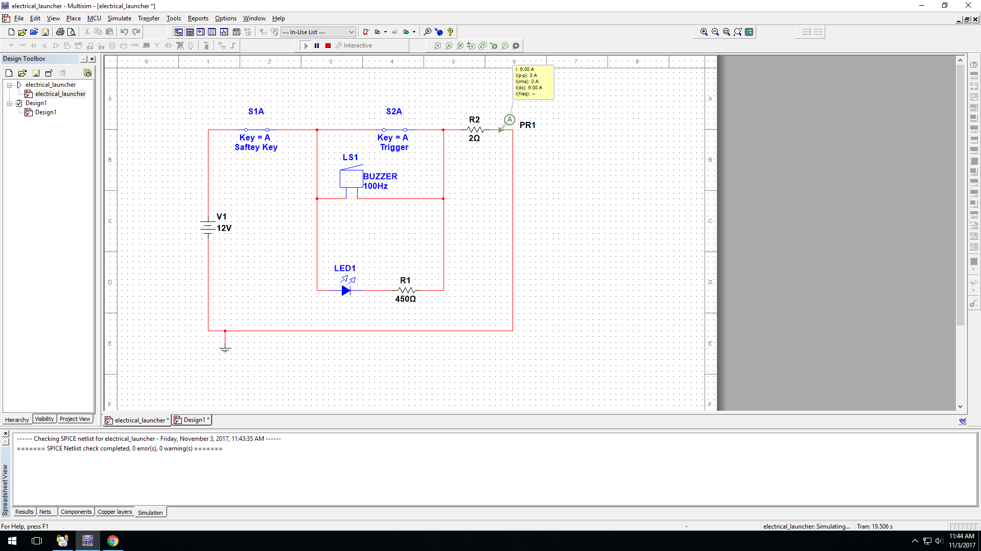

**Figure 20: Multisim Test for Launcher with Switch On**

**Figure 21: Multisim Test for Launcher with Switch and Launch Button on**

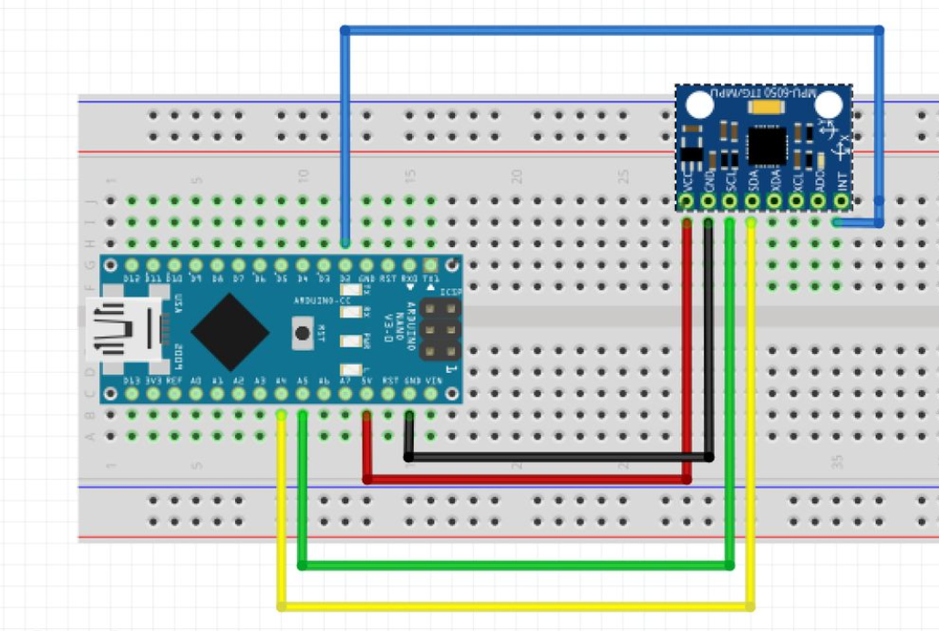

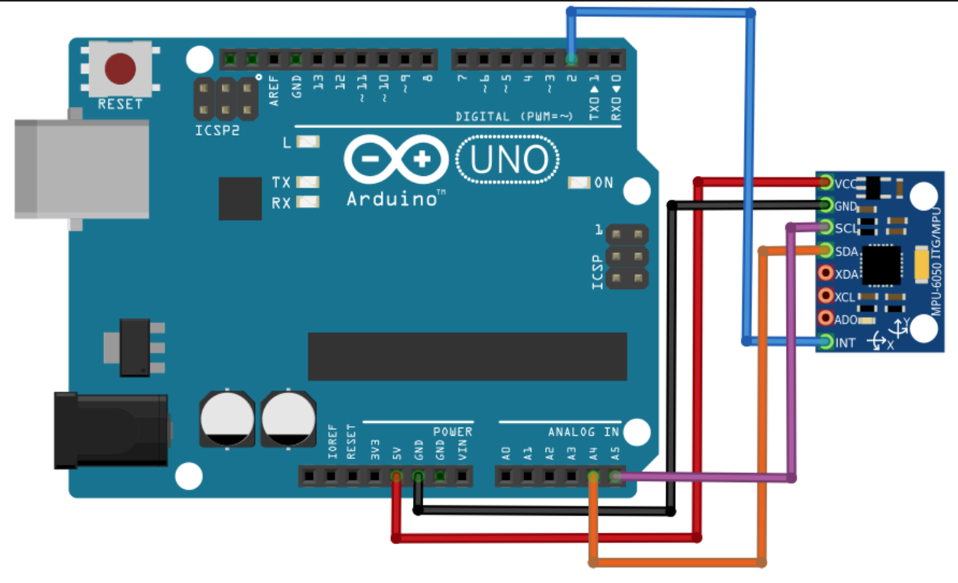

**Figure 23: MPU6050 Pinout Diagram with Nano**

**Figure 22: MPU6050 Pinout Diagram with Uno**

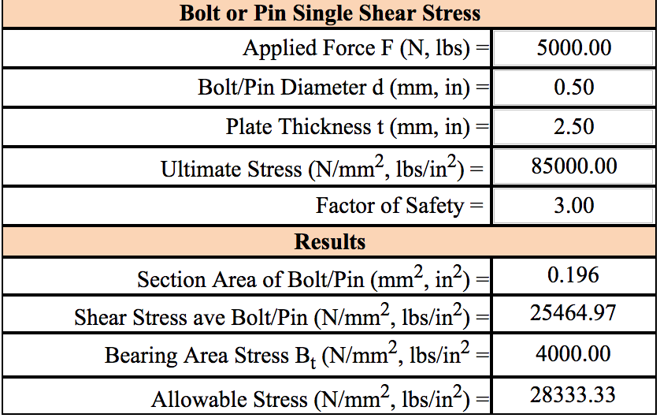

**Figure 23: Bolt Shear Calculator to Test Stress of Engine Force on the Chassis**